UNIVERSITY OF TEXAS AT ARLINGTON

INSY_5339 - PRINCIPLES OF BUSINESS DATA MINING

FINAL PROJECT – SPRING 2020

“STUDENT SCORES ANALYSIS AND PREDCTION”

PRADEEP MEDAGIRI

1001757740

TABLE OF CONTENT:

* Main Objective………………………………………3
* Data Source………………………………………….3

1. Description
2. Attributes

* Summary statistics…………………………………...4

1. Initial Results

* Data Visualization Techniques………………………5

1. Bar Charts
2. Scatter Plots

* Models………………………………………………..8

1. Decision Tree
2. K Nearest Neighbor
3. Random Forest

* Conclusion…………………………………………..13
* References…………………………………………...14

**OBJECTIVE:**

To build three machine learning models for predicting the academic performance of a student by “class” i.e., L(low), M(medium), H(high) using independent variables and to determine which model’s prediction gives the best result, implementing it using SAS.

**DATA SOURCE:**

Data has been acquired from a well know source “Kaggle” an online community of data scientists and machine learning practitioners.

Data Source Link: <https://www.kaggle.com/aljarah/xAPI-Edu-Data>

Dataset consists of 480 student records and 16 features. The features are classified into three major categories:

1. Demographic features such as gender and nationality.

* The dataset consists of 305 males and 175 females. Students from different origins such as Kuwait, Jordan, Palestine, Iraq, Lebanon, Tunis, Saudi Arabia, Egypt, Syria, USA, Iran, Libya, Morocco and Venezuela.

1. Academic background features such as educational stage, grade Level and section.

* The dataset is collected for two semesters: 245 student records are collected during the first semester and 235 student records are collected during the second semester.

1. Behavioural features such as raised hand on class, opening resources, answering survey by parents, and school satisfaction.

* Parent participation feature has two sub features: Parent Answering Survey and Parent School Satisfaction. There are 270 parents that had answered the survey and 210 had not, 292 of the parents had been satisfied from the school and 188 had not.

**ATTRIBUTES:**

|  |  |  |  |
| --- | --- | --- | --- |
| **No** | **Variables** | **Data Type** | **Description** |
| 1 | Gender | String | Gender of the student |
| 2 | Nationality | String | Nationality of the student |
| 3 | Place of birth | String | Place of birth of the student |
| 4 | Educational Stages | String | Educational level that the student belongs |
| 5 | Grade Levels | String | The grade that the student is enrolled in |
| 6 | Section ID | String | Class the student belongs |
| 7 | Topic | String | Course |
| 8 | Semester | String | School year semester |
| 9 | Parent | String | Parent responsible for the student |
| 10 | Raised hand | Numeric | Number of times the student has raised hands |
| 11 | Visited resources | Numeric | Number of times the student visited the course content |
| 12 | Viewing announcements | Numeric | Number of times the student checked the announcements |
| 13 | Discussion groups | Numeric | Number of times the student participated in group discussions |
| 14 | Parent Answering Survey | String | Did the parent answer the survey |
| 15 | Parent School Satisfaction | String | The degree of parent satisfaction from school |
| 16 | Student Absence Days | Numeric | Number of days a student was absent |
| 17 | Class | String | Indicator of the performance of the student (L,M,H) |

The performance of the student is measured by the “class” variable which is divided into three groups.

L-This stands for low level and is given to students who score from 0 to 69

M-This is allotted to students who score somewhere between 70 and 89

H-This comprises of the most successful students who score more than 89 in their tests

**SUMMARY STATISTICS:**

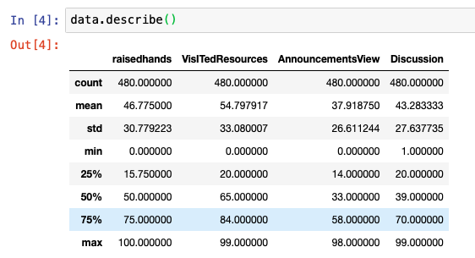

***Initial Results***

1. Data set has a total of 480 observations based on 16 features, having both integer and categorical variables.

2. Data is clean with no missing values, hence performing data pre-processing such as missing value treatments are not required.

3. In this data, by looking at one of the factors i.e., two semesters are considered, both fall and spring with 51% and 49% respectfully, so in this particular case the data is not biased and by following this approach of drilling down with more analytical steps, more insights can be drawn.

**DATA VISUALIZATIONS:**

“Bar charts are used to understand the data. Visuals are produced in tableau”

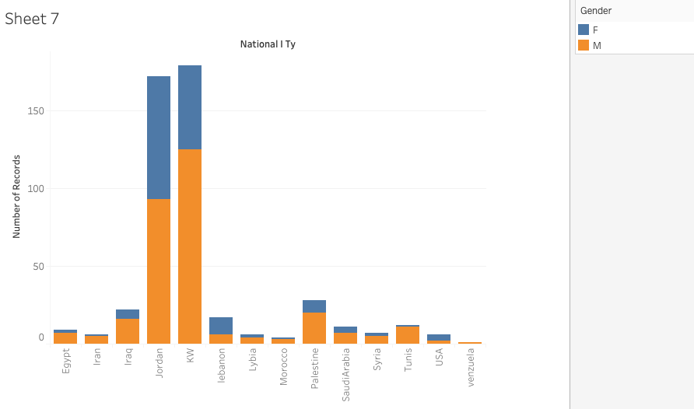

* Gender difference exists across all the countries. However, these differences did not vary much by each country.

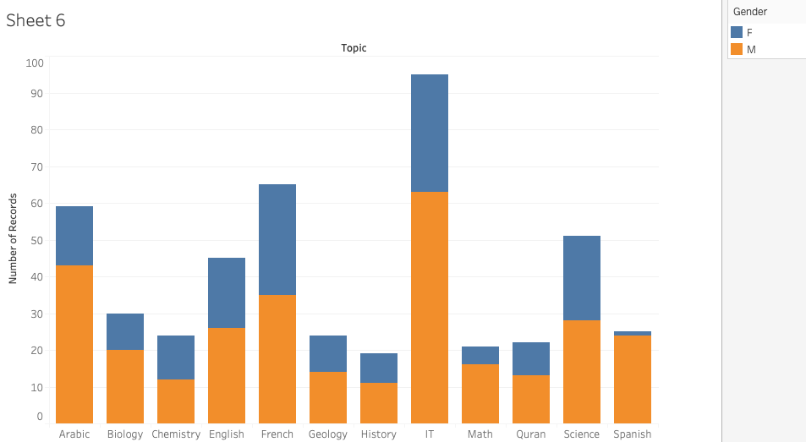

* There is almost no gender bias on choosing subjects. Only math and Spanish are dominated by one gender

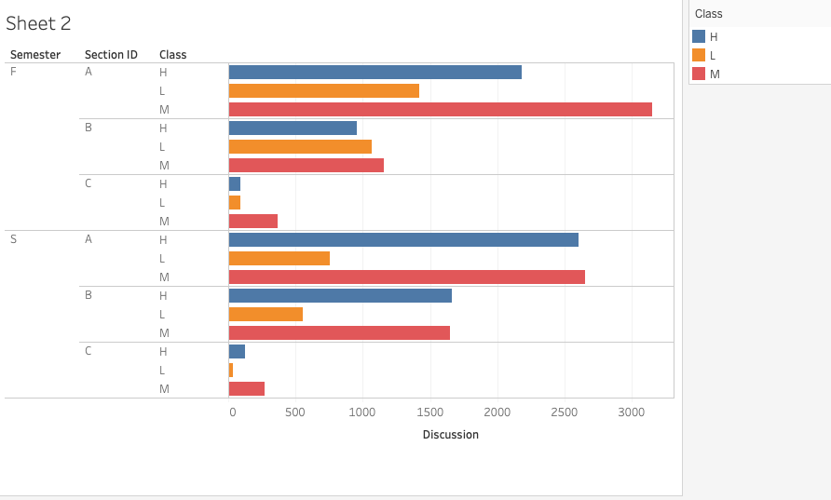

* We can see the discussions in section c are very low compared to other sections in both semesters

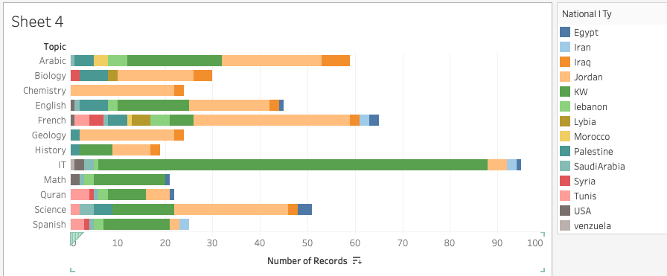

* Some topics are dominated by a single country and some topics are evenly spread out

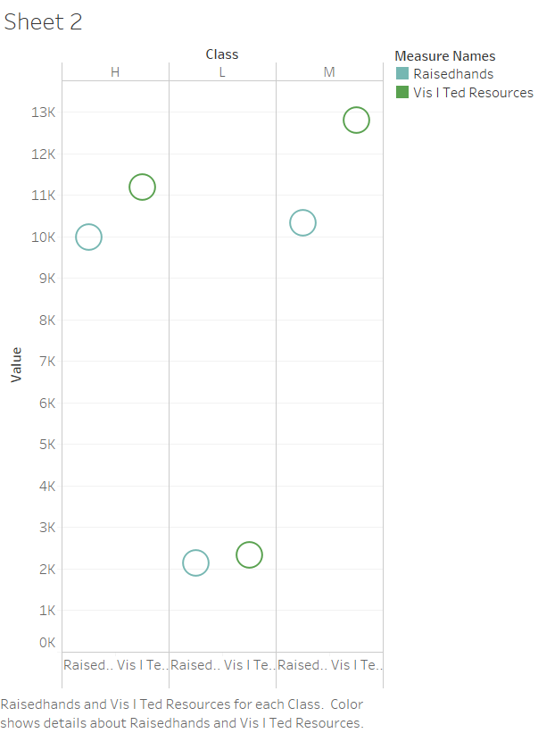

* We can see who ever exhibited low on academic performance used the resources less than the ones who exhibited high or medium level on academic performance

**MODELS:**

As target variable is categorical, so “Decision Tree”, “Random Forest” and “K Nearest Neighbors” predication techniques are used.

***Decision Tree***

* Using decision tree node to get our results

* We split the data into 70%-20%-10%(training-validation-test)
* First split occurred at Student absence days (under 7 days and above 7 days)
* We got average squared error for our target variable Class 0.11 for training data,0.13 for validation data,0.17 for test data
* Student absence days and visited resources both have high variable Importance

***K Nearest Neighbor***

* The Memory-Based Reasoning node assumes that the variables with a model role of "input" are numeric, orthogonal to each other, and standardized. We use the Principal component node to generate numeric, orthogonal, and standardized variables that can be used as inputs for the Memory-Based Reasoning node.
* We select our k value around k=square root of the number of training data which is either 21 or 19 as we should take odd numbers to avoid confusion later. We changed k values accordingly and check them

|  |  |
| --- | --- |
| K=7 | 0.39362 |
| K=11 | 0.42553 |
| K=16 | 0.40426 |
| K=19 | 0.31915 |
| K=21 | 0.29787 |
| K=81 | 0.40426 |
|  |  |

* K=21 has lowest error rate, so we pick 21 nearest neighbors
* We get the following for k-21

|  |  |  |  |
| --- | --- | --- | --- |
|  | **Training** | **Validation** | **Test** |
| **Number of Wrong Classifications** | 112.00 | 28.000 | 21.000 |
| **Misclassification Rate** | 0.34 | 0.298 | 0.404 |

* The above picture shows how many correct or incorrect predictions have been made, class red represents incorrect and blue represents correct

***Random Forest***

* We have observed, visited resources feature has highest variable importance followed by the student absent days feature
* For this algorithm we have

|  |  |  |  |
| --- | --- | --- | --- |
|  | **Training** | **Validation** | **Test** |
| **Number of Wrong Classifications** | 49.00 | 26.000 | 13.000 |
| **Misclassification Rate** | 0.15 | 0.277 | 0.250 |

**CONCLUSION-**

|  |  |  |  |  |  |  |
| --- | --- | --- | --- | --- | --- | --- |
| **Selected Model** | **Model Node** | **Model Description** | **Valid: Misclassification**  **Rate** | **Train: Average**  **Squared**  **Error** | **Train: Misclassification**  **Rate** | **Valid: Average Squared**  **Error** |
| **Y** | HPDMForest | HP Forest | 0.27660 | 0.10924 | 0.14671 | 0.13489 |
| Tree | Decision Tree | 0.27660 | 0.11766 | 0.23653 | 0.13819 |
| MBR2 | k 21 | 0.29787 | 0.15113 | 0.33533 | 0.15151 |

* **From the above picture we can observe cumulative lift for all the predictions**
* **Since this target variable is categorical, we should compare prediction based on misclassification rate rather than average squared error**
* **When we compare the three prediction algorithms, we can ascertain that random forest performed slightly better than both the decision tree and k nearest neighbor algorithms**

**REFERENCE:**

1. Students' Academic Performance Dataset <https://www.kaggle.com/aljarah/xAPI-Edu-Data>

2. Amrieh, E. A., Hamtini, T., & Aljarah, I. (2016). Mining Educational Data to Predict Student’s academic Performance using Ensemble Methods. International Journal of Database Theory and Application, 9(8), 119-136.

3. Amrieh, E. A., Hamtini, T., & Aljarah, I. (2015, November). Preprocessing and analyzing educational data set using X-API for improving student's performance. In Applied Electrical Engineering and Computing Technologies (AEECT), 2015 IEEE Jordan Conference on (pp. 1-5). IEEE.

4. Technologies – SAS Enterprise Miner | Tableau